MGMS – Log-In

Functional Specification Document

Ver. 1.4

Version History
Date | Description

Table of Contents

Version History 2
1 Introduction 4
1.1 Purpose 4
1.2 Scope 4
1.3 Assumptions 4
1.4 Constraints 4
2 Log-In 4
2.1 Forgot your password? 5
3 Business Rules: 6
4 Status Messages 7

Introduction

Purpose

This document provides the requirements and functional specifications for the Multisite Grant Management System project.
This is not a project plan or a design document. It is a guide for system architecture and development, not for phasing, timelines or deliverables.
Finally, this is a ‘living document’ and the specification will change, continuously, as the project proceeds. More details will be added and the existing information edited as the requirements, scenarios and use cases evolve in the course of the project.

Scope

Assumptions

Constraints

Log-In

Screen & Control Description

Figure 1: Log-In
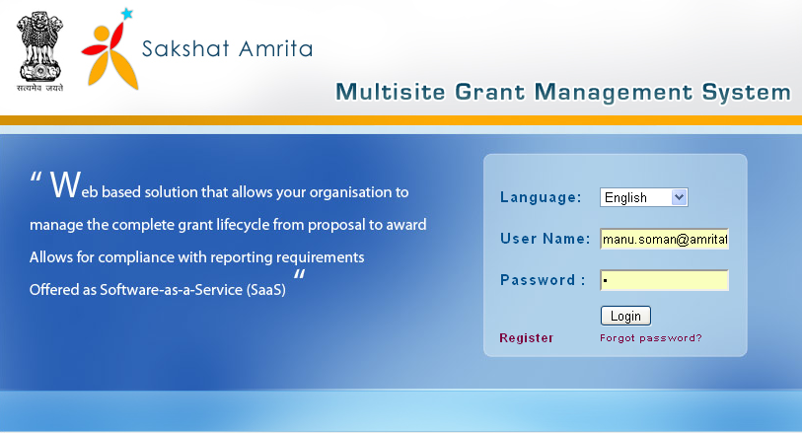

Field /Label | Input-Control | Data Type | Details
Langauge | Listbox | String | Required
User Name | Textbox | String | Required
Password | Textbox | String | Required
Login | Button
Register | Link | Opens page – “Create site admin” where the user should register on behalf of his institution.
Forgot Password? | Link | Opens page for creating new password and send to user’s email id (activation link)

Forgot your password?

Screen & Control Description
Figure 2: Forgot your password
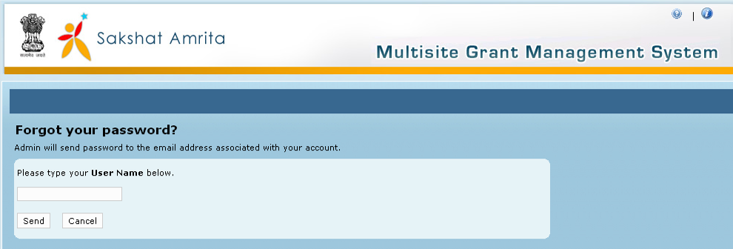

Field /Label | Input-Control | Data Type | Details
Forgot your password?
Admin will send password to the email address associated with your account.
Please type your User Name below. | Textbox | String | Required
Send | Button |  | System will send password to the email address associated with the user name entered above.
Cancel | Button |  | System returns to the Log in page

Click on the button which will send password and account activation link to the email id entered. Through the activation link provided in mail user can re-activate the account.

Assumptions:

Business Rules:

Since there will be many institutions who are users, will log in screen give list box options to choose country (future enhancement), network etc?

Status Messages

Sl No | Status Message
1 | Created Successfully
2 | Updated Successfully
3 | Deleted Successfully
4 | The Requested Record Not Found
5 | The Record can't be deleted, Already in use
6 | The Record Already Exists
7 | Please Enter a valid email address
8 | You can not delete yourself, please login as another admin and try again
9 | User Name already exists
10 | Old password not correct
11 | Password changed
12 | Password not changed
13 | Institution Already Exists
14 | There is no email address associated with this User Name
15 | Please enter a valid User Name
16 | The passwords you entered do not match.
17 | Default Role not found.
18 | Access code did not match.

